# The Impact of Fast Food on Children’s Health

## Abstract:

The fast-food industry, particularly in its relationship with children, presents significant public health challenges. Although fast food is often perceived as affordable, convenient, and appealing—especially due to aggressive marketing strategies aimed at young consumers—the potential dangers it poses to children's health are frequently overlooked. This project investigates the negative impact of fast food on children's well-being, focusing on growing concerns over nutritional deficiencies, obesity, and associated health risks. The main objective of this study is to evaluate how fast-food influences children's health and to analyze public awareness of the related health risks and ethical issues inherent in the fast-food industry.

## Introduction:

The fast-food industry has become a fixture in modern society, with fast-food outlets visible on almost every corner of urban spaces. Over the past several decades, the popularity of fast food has skyrocketed, largely due to its convenience, affordability, and mass appeal—particularly among children. However, beneath its surface of convenience and enjoyment lies a growing concern regarding its adverse health effects, especially in younger populations. Children, who are the primary targets of fast-food marketing campaigns, are particularly vulnerable to its negative consequences, which include poor nutrition, obesity, and an increased risk of chronic diseases such as type 2 diabetes, heart conditions, and certain cancers.

The purpose of this project is to explore the significant impact that the fast-food industry has on children’s health and to examine the broader social and ethical concerns surrounding its business practices. Beyond its health implications, fast food has been criticized for a variety of other issues, including unsanitary conditions in some restaurants, the use of unhealthy ingredients, environmental pollution, and exploitative labor practices.

The scope of this project encompasses an analysis of how fast-food consumption affects children's health, particularly in terms of childhood obesity and related illnesses. It also considers the environmental, social, and ethical implications of the fast-food industry. By comprehending the full impact of fast food on society, this project aims to raise awareness about the need for healthier food options and stricter regulations to protect vulnerable populations, especially children.

## Methodology:

This project employs a multi-faceted approach to evaluate the effects of fast food on children's health, utilizing data analysis, research from credible sources, and statistical tools. The methodology is divided into several key steps:

### 1. Literature Review:

The first step involved reviewing academic articles, reports, and studies on the fast-food industry’s impact on children's health. Key sources included peer-reviewed journals, government health statistics, the book *Fast Food Nation* by Eric Schlosser, and reputable health organizations such as the CDC and WHO. This review provided foundational knowledge on topics such as childhood obesity, nutritional deficiencies, and long-term health risks.

### 2. Data Collection:

Data related to fast-food consumption rates among children, the nutritional content of popular fast-food items, and trends in childhood obesity were collected from public databases and research studies. Key sources included:

* USDA Food and Nutrition Database
* CDC Childhood Obesity Data
* News Medical Life Sciences

### 3. Data Analysis Using Excel:

Microsoft Excel was employed to organize, analyze, and visualize data. Specific techniques included:

* Data Entry & Cleaning: Collected data was entered into Excel spreadsheets, ensuring consistency and accuracy in categorizing variables like age groups, calorie intake, and health outcomes.
* Statistical Functions: Functions such as AVERAGE, MEDIAN, and STDEV were used to calculate average calorie intake from fast food, mean BMI (Body Mass Index) in children, and standard deviation for health outcomes.
* Data Visualization: Graphs, charts, and tables were generated using Excel’s charting tools to visually represent trends and correlations. For instance, a line graph illustrated the correlation between rising childhood obesity rates and increasing fast-food consumption (See Charts).

### 4. Case Study Analysis:

A detailed analysis of case studies was conducted to assess the direct impact of fast food on children’s health in different demographic groups.

### 5. Conclusion Development:

Based on findings from the data analysis and case studies, conclusions were drawn about the overall influence of fast food on children’s health. Recommendations were developed for reducing negative effects through improved dietary choices, public policy initiatives, and stronger industry regulations.

## Results:

When we think about fast food, what often comes to mind are affordability, speed, convenience, flavor, and enticing marketing extras like toys in kids’ meals. However, the potential dangers of fast food are frequently overlooked, particularly its negative impact on children's health.

The Food and Drug Administration (FDA) has mandated that fast-food restaurants become more transparent by providing clear labeling of nutritional facts and easy-to-understand ingredient information. However, many fast-food chains, including major players like McDonald’s and Burger King, continue to resist full transparency, making it difficult for consumers to make informed choices.

Data shows that regular fast-food consumption is strongly linked to serious health problems. Studies reveal that children derive between 29% and 38% of their total food intake from fast food. Over time, this can lead to significant weight gain, with children gaining an average of 6 pounds per year from fast food alone. A child aged 5 to 15 could potentially gain as much as 60 pounds over a decade due to fast-food consumption. This weight gain directly correlates with the rising rates of childhood obesity in the U.S. (See Chart 1).

Statistics show that children who consume fast food regularly are more likely to suffer from long-term health issues such as type 2 diabetes, cardiovascular disease, and certain types of cancer. The prevalence of childhood obesity in the U.S. has tripled in the last three decades, with approximately 20% of children and adolescents classified as obese. This is especially concerning because obesity in childhood is linked to a higher risk of adult obesity, along with a range of chronic diseases (See Chart 2).

Furthermore, eating patterns among children in the U.S. show that many fail to meet recommended nutritional guidelines. According to USDA data:

* 16% of children fail to meet any of the Recommended Dietary Allowances (RDA) for essential nutrients.
* Only 1% of children meet all the recommendations for a balanced diet.
* Around 70% of children between ages 2 and 19 do not consume the recommended servings of fruits, grains, dairy, or protein.
* 64% do not meet the recommended daily servings for vegetables (See Chart 3).

Additionally, significant disparities exist in children's eating behaviors based on gender and ethnicity. For example, Hispanic and Black children in the U.S. are disproportionately affected by obesity and related health risks, highlighting a complex intersection of social, cultural, and economic factors.

## Charts

Chart 1

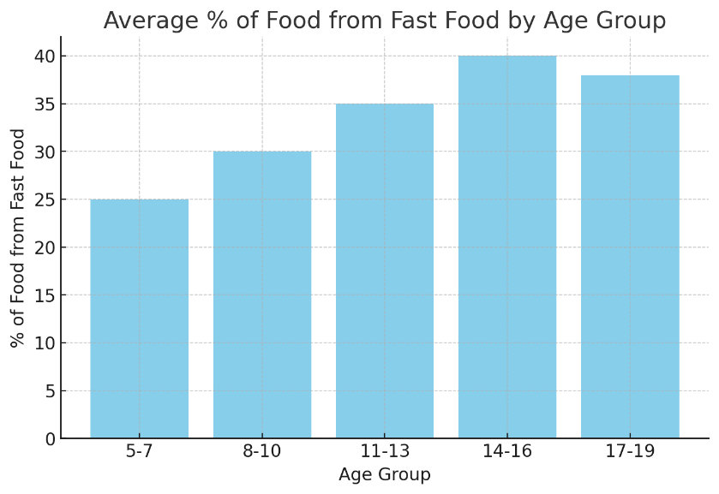

Chart 2

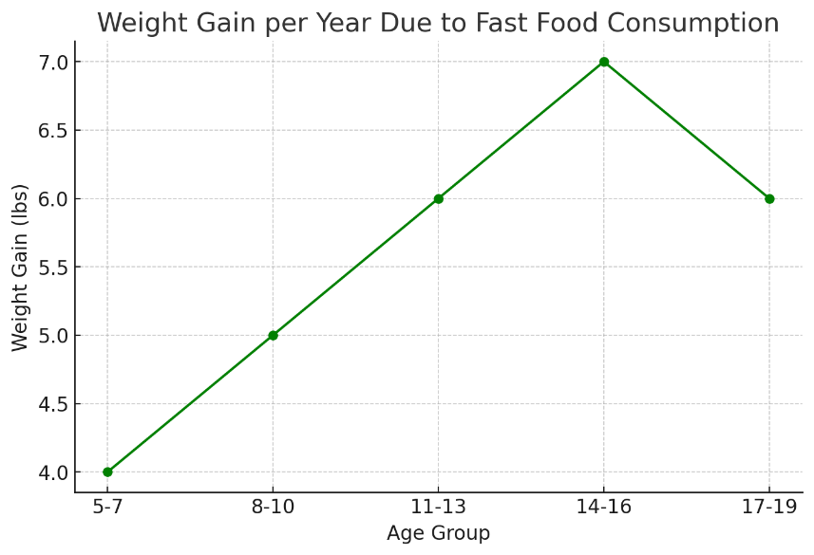

Chart 3

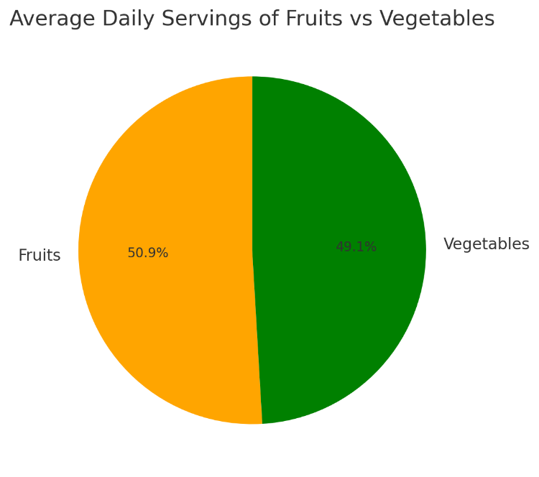

## References

Harvard Health Publishing. (2013, January 31). *Think fast when kids want fast food.* Harvard Health. <https://www.health.harvard.edu/blog/think-fast-when-kids-want-fast-food-201301315846>

C.S. Mott Children's Hospital. (2021, September). *Fast food for kids: How young is too young?* C.S. Mott Children's Hospital National Poll on Children's Health. <https://mottpoll.org/sites/default/files/documents/092021_FastFood.pdf>

Bleich, S. N., Economos, C. D., Spiker, M. L., Thorndike, A. N., & Li, Z. (2023). *Fast food consumption and its associations with diet quality and health: Results from a national survey*. The American Journal of Clinical Nutrition, 118(4), 1023-1033. <https://doi.org/10.1016/j.ajcnut.2023.06.023>

Palermo, E. (2023, May 9). *How fast food affects children's health.* News Medical. <https://www.news-medical.net/health/How-Fast-Food-Affects-Childrens-Health.aspx>

U.S. Department of Agriculture, Food and Nutrition Service. (n.d.). *Nutrition education.* <https://www.fns.usda.gov/nutrition-education>

Petre, A. (2019, February 8). *How fast food affects the body.* Medical News Today. <https://www.medicalnewstoday.com/articles/324847>

Poti, J. M., Mendez, M. A., Ng, S. W., & Popkin, B. M. (2016). *Is the degree of food processing and convenience linked with the nutritional quality of foods purchased by US households?* The American Journal of Clinical Nutrition, 101(6), 1251-1262. <https://doi.org/10.3945/ajcn.115.100596>

U.S. Department of Agriculture, & U.S. Department of Health and Human Services. (2020). *Dietary guidelines for Americans, 2020-2025* (9th ed.). <https://www.dietaryguidelines.gov/sites/default/files/2021-03/Dietary_Guidelines_for_Americans-2020-2025.pdf>

Aubrey, A. (2021, August 11). *Study finds U.S. kids' diets are dominated by ultra-processed junk food.* NPR. <https://www.npr.org/2021/08/11/1026816658/study-us-kids-diet-ultraprocessed-junk-food>